Summary of Useful Expressions for 25% CA Assignment

For 1: Greet your colleague and introduce yourself
Hi! Nice to meet you. I’m ___________ from the ___________ Department.

For 2a: Making small talk (Unit 2)
- Using echo words (4ai-iii)
e.g. A: ‘I went to Tokyo Disneyland during my annual leave.’
B: ‘Disneyland? That sounds fun!’
- +ve comments or compliments (4bi-iii)
e.g. Chris: ‘They served Italian food and I had the best lasagna I’ve ever tasted.’
Jack: ‘Wow, I also love a good lasagna.’
- Asking follow-up questions and bringing up new topics
- echo question (4c ii- v) Did you? Disney sounds exciting.
- Wh- question (4c vi-xii) How do you like the rollercoasters and shows?
- yes/no question (4c xiii – xv) Did you try their restaurants?

Examples of talking about your upcoming holiday plan

- I’m heading to beautiful Bali next month and I genuinely can’t wait to unwind. I’ve booked a quiet villa with a private pool and plan to do absolutely nothing but read, sunbathe, and maybe take a refreshing surfing lesson.
- I’m so excited for my highly anticipated holiday in vibrant Taiwan. I plan to eat lots of delicious street food at the bustling night markets and see the amazing, breathtaking views from the iconic Taipei 101. It will be my fantastic first time visiting, and I can’t wait to explore.

- I plan to go to Japan. I’m excited to explore the bustling streets of Tokyo, where I can visit iconic landmarks like the Tokyo Tower and the Meiji Shrine. I also want to visit Kyoto’s peaceful temples and beautiful gardens. I can’t wait to try delicious sushi and ramen, and see the amazing views of Mount Fuji.

- I’m going to Australia with my family. I want to see the famous Sydney Opera House and visit the amazing Great Barrier Reef. I also hope to see koalas, kangaroos and other wildlife. I’m really excited for this big adventure.
- My plan for the holiday is simple. I will stay home, sleep a lot, order my favorite foods, and watch good movies. I just want a peaceful and restful break.

For 2b: Making small talk – Talking about work projects (Unit 4)
- Tenses used: 3 stages (Task 3)
  - Task completed (present perfect tense)
  - Task in progress (present continuous tense)
  - Work to complete (future tense)

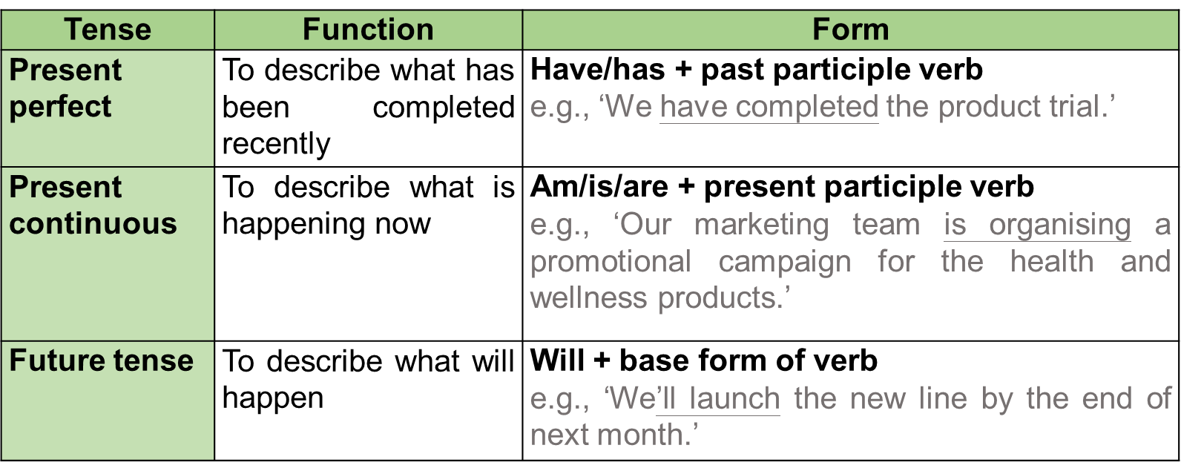

Examples: (Task 3aii-ix practice)
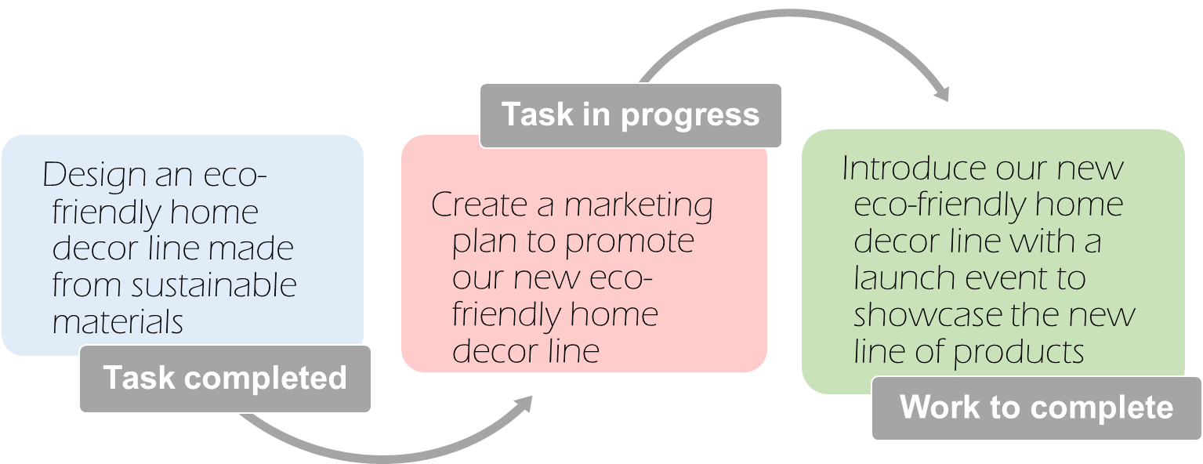
‘We are currently creating (create) a marketing plan to engage our target audience and promote our new eco-friendly home decor line. So far, we have designed (design) an eco-friendly home decor line made from sustainable materials. Next, we will introduce (introduce) our new eco-friendly home decor line with a launch event to showcase the features of the new product line.’

Useful words and phrases:
- Currently, …… (present continuous tense)
e.g. Currently, the marketing team is launching social media contests
e.g. I am happy to tell you that we are currently liaising a new advert plan with a renowned YouTuber ……

- So far, …… (present perfect tense)
e.g. So far, we have designed an eco-friendly home decor line made from sustainable materials.
e.g. Our team has already kicked off a trial of the new system.

- Next, ……. (future tense)
e.g. Next, we will introduce our new eco-friendly home decor line……
e.g. If everything goes well as planned, we anticipate a rise in sales in all our outlets.

Giving details:
- ……. to (purpose) / To (purpose), …….
e.g. Next, we will introduce our new mobile application with a launch event to showcase the features and membership plans. (purpose)
e.g. To encourage purchases (purpose), we will offer exclusive discounts and promotions to email subscribers and social media followers to retain existing customers and attract new ones.’
e.g. To achieve this (purpose), we have partnered with experienced designers and manufacturers to create a collection that embodies our brand’s values and aesthetic.
- ……. including ……. (details)
e.g. We’ll provide the influencers with detailed product information, including the features and benefits, (details) to let them create content for posting on their own social media accounts. (purpose)
- ……. so that …… (results)
e.g. we will conduct tests to ensure that the pages of the new product line function smoothly (purpose) so that our customers can have a seamless shopping experience. (result)

For 3: Share your opinions on a new company policy (Unit 5)
Starting a conversation (about company facilities/ policies/ employee benefits) | Have you heard about …?
 | What do you think about…?
 | Did you hear about…?
Expressing opinions | I think/feel/believe/reckon/love
Expressing opinions | In my view/opinion, …
Expressing opinions | On the one hand, … On the other hand, …
Stating causes | …because/since/as…
Explaining effects | so…
Explaining effects | As a result, …
Explaining effects | Therefore/ Consequently, …
Sharing personal experiences | My position is that …
Sharing personal experiences | Personally speaking, …
Sharing personal experiences | My personal feeling is that…
Sharing personal experiences | My own experience is that…
Giving examples | For example/instance, …
Positive: ‘Fantastic! I love this policy as I will be able to spend time with my dog at work. I feel that having pets in the office can definitely improve/enhance the atmosphere. It will be fun to see different pets, too. For example, some staff members may bring their cats or dogs, while others may bring more exotic pets, such as tortoises or parrots. I really believe that this pet-friendly policy is meaningful since having pets around can reduce the stress of many staff members and improve/enhance their work output.’

Negative: ‘While I understand your view, I tend to think that it is quite inappropriate to have animals in the office because they can be very disturbing. It will be hard to concentrate with animals around. This may decrease productivity. In addition, I feel that no consideration has been given to health and safety issues. There are people who don't like animals or are allergic. This policy is unfair to them. In my opinion, we should focus on work in the office and keep our pets at home.’

Neutral: ‘I have mixed feelings about Pet Day. On the one hand, having pets at work could be beneficial to some staff members and boost morale. On the other hand, the pets could be disruptive and noisy. It is a bit impractical to implement this policy every month. Perhaps we could consider a compromise, like running Pet Day twice a year. This may be more effective.’

Positive adjectives | Negative adjectives |  | Positive verbs | Negative verbs
accommodating  beneficial  considerate  convenient  effective / cost-effective  flexible  generous  valuable  helpful  meaningful  morale-boosting  practical  progressive  staff-friendly  supportive  useful  worthwhile | disappointing  disruptive  disturbing  impractical  inappropriate  inconsiderate  inflexible  restrictive  rigid  short-sighted  underwhelming  unfair  unreasonable |  | increase  improve  enhance  boost  enrich  promote  help  encourage  support  create | decrease  reduce  worsen  impair  hinder

For 4: End the conversation politely
- I’d love to chat longer, but I really must run. See you soon.
- Sorry, I’ve got to go now, but I hope to see you around.
- Sorry, I have to attend a meeting now. Let’s meet for lunch next week though.
- It’s been lovely to meet you. Hopefully, I’ll see you around.
- It’s nice to meet you too. Have a great day!

